**CKM0003 COKOINO Three-way Link-tracking Module**

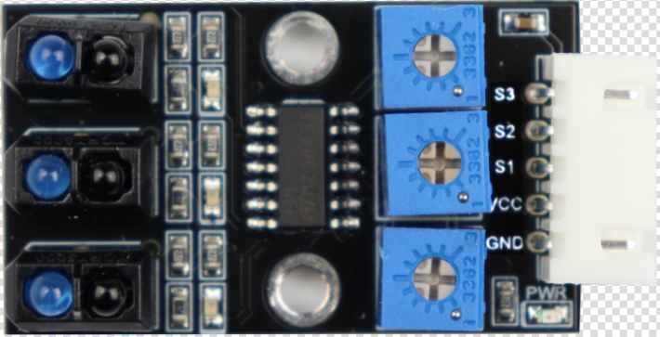

**1、Overview**

The COKOINO three-way Link-tracking Module is compatible with the Arduino platform. The working principle of the TCRT5000 infrared pair tube on the module is to convert the intensity of the reflected signal into a digital signal after emitting infrared rays, because the emitted infrared rays have different reflectances according to different colors.

The sensor outputs a high level when black is detected and a low level when white white is detected. The module comes with 2 positioning holes, which can be fixed it on other devices. Combined with arduino uno r3 motherboard and other modules, it can be combined into various interesting products, such as: black line-tracking smart car, obstacle detection car, etc.

**2、[specification](D:/Youdao/Dict/8.1.1.0/resultui/html/index.html" \l "/javascript:;) [parameter](D:/Youdao/Dict/8.1.1.0/resultui/html/index.html" \l "/javascript:;)**

(1) Working voltage: recommended working voltage 5V  
(2) Detection distance: maximum 3CM  
(3) Output signal: digital signal  
(4) Interface: XH2.54-5P

**3、Size（mm）**

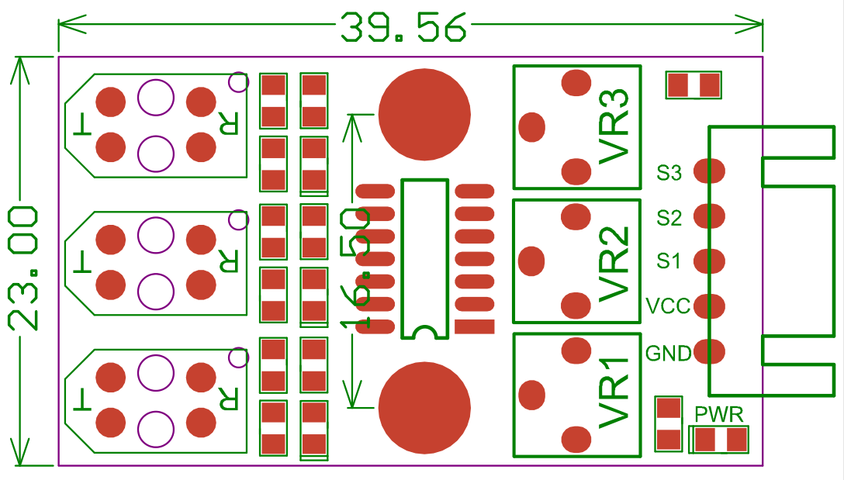

**4、Pins**

GND: Connect the negative pole of the power supply  
VCC: Connect the positive pole of the power supply  
S3: Third road inspection signal output  
S2: second road patrol signal output  
S1: The first road inspection signal output

**5、Working principle**

(1) The infrared emitting diode of the sensor continuously emits infrared rays. When the emitted infrared rays are not reflected back or the rays reflected back is not large enough, the phototransistor is always in the off state, the output end of the module is always at a low level. The LED light is illuminated;

when the detected object appears in the detection range, the infrared light is reflected back and the intensity of it is large enough, and the phototransistor is saturated, the output end of the module is high, the LED light is off.

Reminder: The infrared light emitted by this module is easily reflected by white objects and is easily absorbed by black objects.

1. We can adjust the detection sensitivity by rotating the blue potentiometer of the module, and adjust the blue potentiometer until the LED on the module is just extinguished, and the sensitivity is the best.  
   (3) RV1 corresponds to adjust the sensitivity of S1 output, RV2 corresponds to adjust the sensitivity of S2 output, and RV3 corresponds to adjust the sensitivity of S3 output.
2. **6、Wiring**

|  |  |
| --- | --- |
| UNO R3 controller | three-way Link-tracking Module |
| GND | G |
| 5V | V |
| 3 | S1 |
| 4 | S2 |
| 5 | S3 |



1. **Arduino code**

void setup() //Set parameter function, the program will only run once after startup

{

Serial.begin(9600); //Set the serial port baud rate to 9600

pinMode(7,INPUT); //The pin is set to output mode

pinMode(8,INPUT);

pinMode(9,INPUT);

}

void loop() //Main loop function

{

Serial.print("S1:"); //Serial port print S1

Serial.print(digitalRead(7)); //The serial port outputs the values read from the digital port 3

Serial.print(" ");

Serial.print("S2:"); //Serial port print S2

Serial.print(digitalRead(8)); //The serial port outputs the values read from the digital port 4

Serial.print(" ");

Serial.print("S3:"); //Serial port print S3

Serial.println(digitalRead(9));//The serial port outputs the values read from the digital port 5, and the line breaks automatically

delay(1000); //delay 1000ms

}

**8、Test result**

1.Wiring according to the above picture, upload the code to UNO, after power-on, open the IDE's serial monitor, set the baud rate to 9600, when the 3-way line-tracking module detects black objects, the signal output high level, The serial port monitor shows as 1, the LED on the 3-way line-tracking module is off;

2.when the other line-tracking module detects other colors, the signal output is low, the serial monitor displays 0, and the LED on the 3-way line-tracking module lights up.

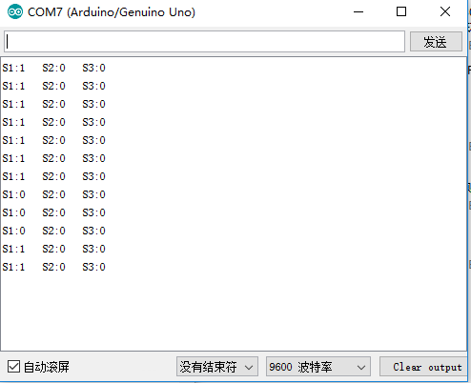

**9、Schematic**

